Helen Shembo  
Brewer Alexandra  
WRI 0105  
27 May 2024

1. What will you describe?

Of all these great places in the world, Central Park is one of the places that I am so familiar with and have been to numerous occasions.

2. What is your reason for choosing this place? Be as specific as possible.

Division based on the separation of nature and city life gives rather number of opportunities for the detailed and rather clear descriptions of the scenes.

3. What specific impression do you want to create?

I want my audience to be left with feeling that there is order in this world and that nature and man-made structures coexist in a peaceful and aesthetically appealing manner.

4. How will you organize your essay?

In the work, I will indicate that the first part of the park presents elements from the right part of the picture up to the left one.

5. Fill in the following chart with as many details as possible.

|  |  |  |  |  |
| --- | --- | --- | --- | --- |
| SIGHT | SOUND | TASTE | TOUCH | SMELL |
| People standing and talking on the right. | People laugh and chat. | Flavored drinks or snacks (eg ice cream, lemonade) brought to the park to enjoy. | Soft, cool grass underfoot. | It smells like freshly cut grass. |
| People sit by the fire. | The leaves are rustling in the wind. |  | The warmth of the sun on the skin. | The smell of flowers and trees. |
| The wide green grass stretches to the sky. | The sounds around the park, including the distant city traffic. |  | The breeze blows against your face. | The smell of food from a nearby vendor. |
| People lying on blankets in the sun. | He gets occasional shouts from people playing the game. |  | The rough construction of a picnic blanket. | A hint of city air mixed with the scent of nature. |
| A dense tree line creates a natural barrier. | The birds are chirping in the trees. |  | Flat garden bench. |  |

**Selected location:**

Central Park, New York City.

**Picture:**

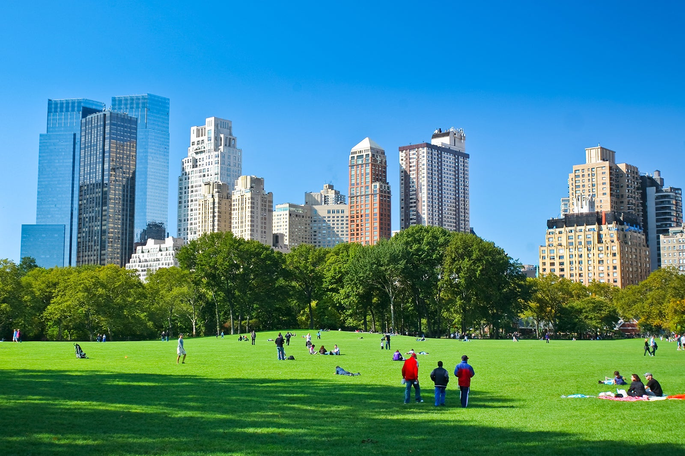

**Image Description:**

There are people having fun in Central Park on a sunny day, and the sky is clear blue. The grounds are green, and the buildings are tall.

**Plans**

**Overview:**

At its best, Central Park is an urban green zone with an active pace of life immersed in the chaos of NY.

**Outline:**

**Details:**

Right:

An assembled group of individuals wearing no formal or traditional garbs are standing and having a conversation.

Some people sit by the fire and start their own business Some people bare their behinds to the public Some people paint their nails and put on lipstick and wear a short skirt and go robbing Som people sit by the fire and start their own business.

Before:

Green and expansive grass extends only as far as the eye can see up into the sky.

Some drive about in cars, while others sit on blankets to enjoy the sun.

Then:

If there are a big tree around it then the leaves serve as partitions.

This is a spectacular view due to the high rise buildings around New York especially atop which are green vegetations.

Left:

Recreation such as kids playing with a frisbee with their friends or groups of friends having taken a meal on a picnic.

Comfort makes a joyful home for a poor man.

**Conclusion:**

Looking at the landscape of accessible areas for rest, Central Park can be recommended as a great opportunity to escape from the everyday civilization problems for city people with remains of nature mixed with city atmosphere.

**First Draft:**

NYC is an urban city and Central Park adds the feel of a green lungs that is surrounded by concrete jungles. To the right of it, subjects in backless, free-flowing clothing converse; several individuals are seated next to the fire, busy with their tasks. In front of it, an enormous grassy area aims at touching the sky and several people can be seen lying down on the grass, completely relaxed. Behind them a line of trees to make it natural. In the background there are towering skyscrapers of New York City – they look proud, but at the same time they seem to be rather out of place here and are in contrast to the green surroundings. On one side there is a group of friends this time few in number and they are playing or having a picnic the sound of their laughs. The average person cooks, eats, gains energy, rests and becomes comfortable, gets fresh air. This place is exceptional when it comes to the normal people who live in the city, who can fully understand and identify with the bond between nature and concrete jungle with lush greens.

**Polish Draft:**

**A Day in Central Park:**

NYC is an urban city and Central Park adds the feel of a green lungs that is surrounded by concrete jungles. To the right of the park, people in backless, free-flowing clothing converse; several individuals are seated next to the fire, busy with their tasks. In front of the park, an enormous grassy area aims at touching the sky and several people can be seen lying down on the grass, completely relaxed. Behind them, a line of trees to make it natural. In the background, there are towering skyscrapers of New York City – they look proud, but at the same time they seem to be rather out of place here and are in contrast to the green surroundings. On one side, there is a group of friends this time few in number and they are playing or having a picnic the sound of their laughs. The average person cooks, eats, gains energy, rests and becomes comfortable, gets fresh air. This place is exceptional when it comes to the normal people who live in the city, who can fully understand and identify with the bond between nature and concrete jungle with lush greens.